Rhythm Game

Custom Project Final Report

Spring 2018

Cody Khuu

Table of Contents

**Introduction** **3**

**User Guide** **4**

**Hardware** **5**

Parts List 5

Pinout 5

**Software** **6**

**Complexities** **9**

Completed Complexities: 9

**Youtube Link** **9**

**Known Bugs and Shortcomings** **9**

**Future work** **9**

# Introduction

This Rhythm Game has three to four buttons that need to be pressed when notes reach the start bar. The concept of this game is to match the notes with a corresponding button press at certain times and areas in the play area. If the player presses the button at the correct time then he/she would get points. The player is only to be pressing one at a time or else points are not granted. The point of the game is for the player to gain as much points as possible. Once the song is completed, the player would see their score and if their score is higher than the previous high score then it would replace it in the high score screen, otherwise it would stay the same.

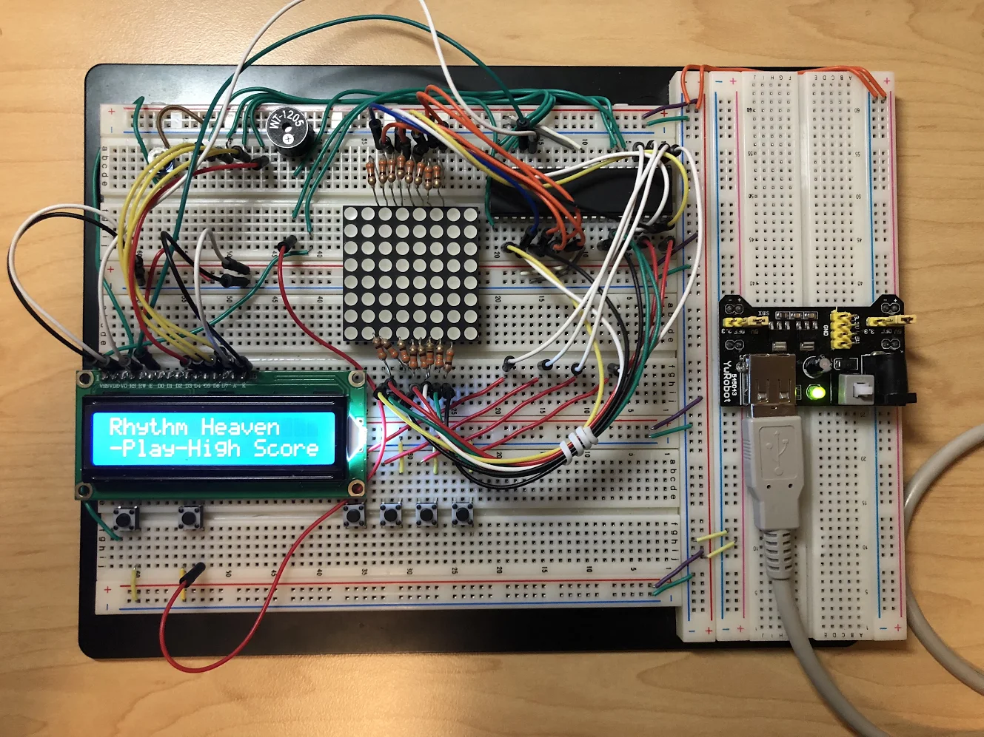

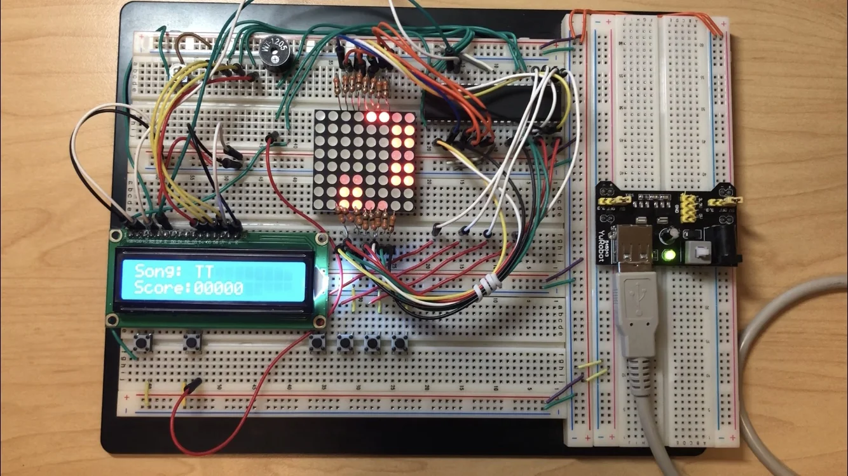

# User Guide

In this project there is a play button, next menu button, and four buttons that coordinate with the 1st, 2nd, 3rd, and fourth column of the LED Matrix. The game starts at a menu pase where the user can only press the play button or the next menu button. When the game starts the user can only press the four button inputs. If the player presses the inputs in the correct column and when the LED Matrix lights up at the bottom of the LED Matrix, the user is awarded with a point. Once the game has finished the LED Matrix will entirely light up and the score is shown. If the score is higher than the previous high score the LCD display will say “New High Score” otherwise it would say “Total High Score” with a prompt telling the play to press the menu button to either play again or see the high score screen again.

# Hardware

## Parts List

The hardware that was used in this design is listed below. The equipment that was not taught in this course has been bolded.

* ATMega1284p microcontroller
* Buttons
* Speaker
* **8x8 LED Matrix**
* **4 Pin LCD Screen** (instead of 8 from the lab)

## Pinout

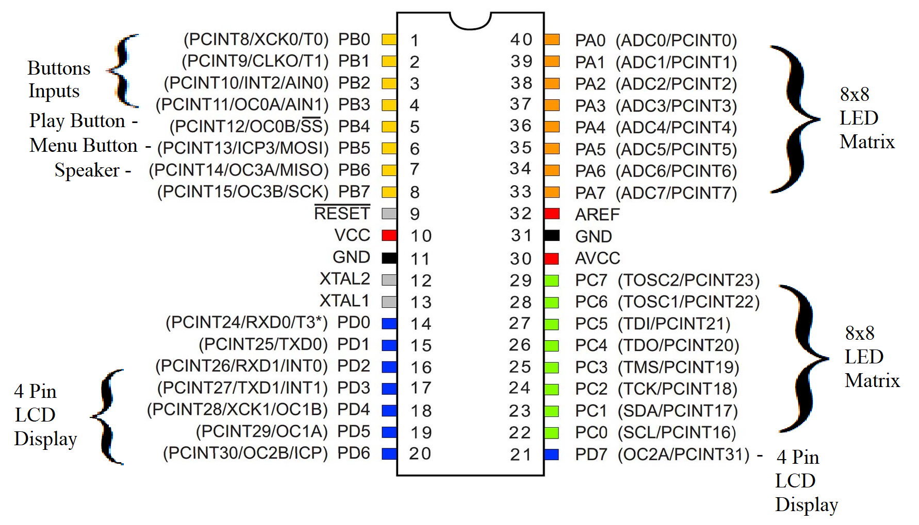

# Software

**LED_DISPLAY State**

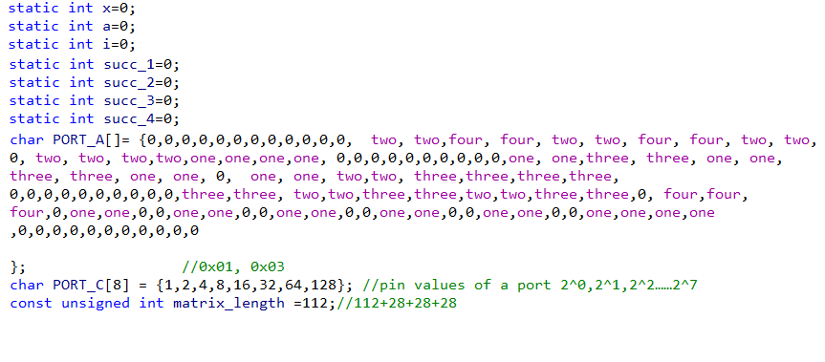

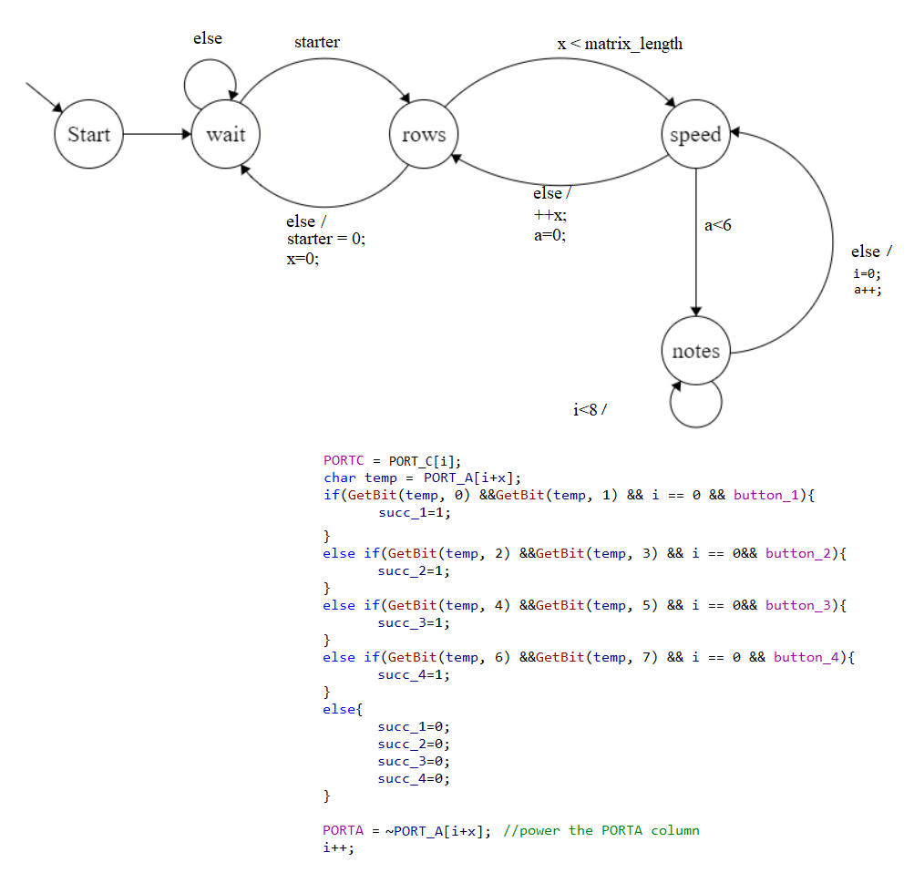

**Song States**

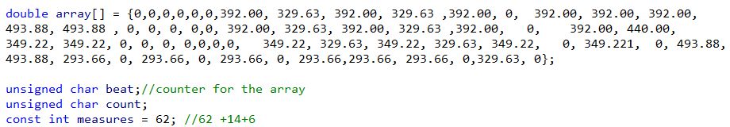

Set_PWM(double val);// changes the frequency of the noise maker

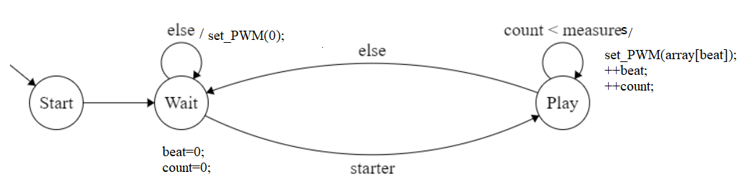

**LCD_Display & Game Logic State**

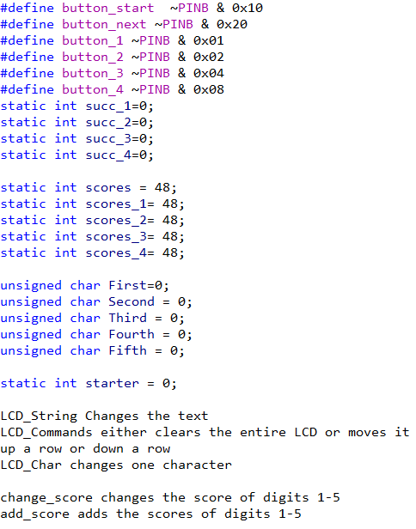

**//change_score also updated the score by using eeprom**

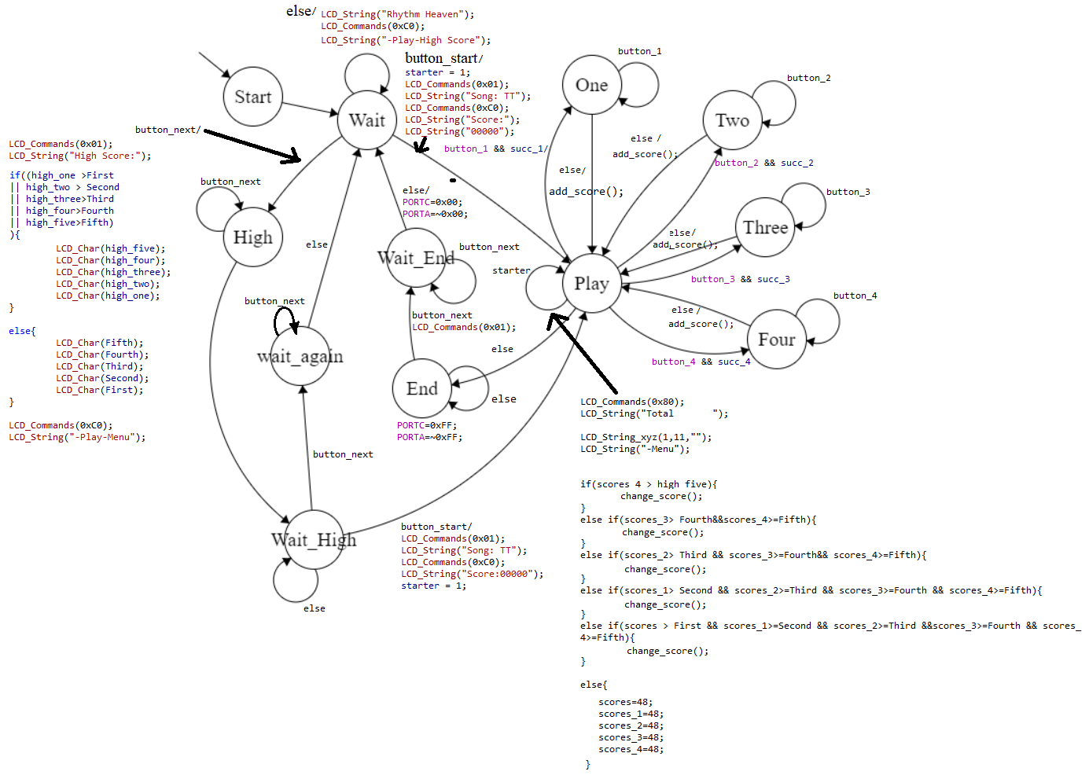

# Complexities

## Completed Complexities:

* 8x8 LED Matrix: Shows when you need to press inputs at the correct time
* EEPROM: To save the High Score
* 4 Pin LCD Display: To save space
* Core Game logic: To add up the score if buttons are pressed at the correct time and save scores(If there is a new high score)

# Youtube Link

<https://www.youtube.com/watch?v=acBHFVkrooQ>

# Known Bugs and Shortcomings

* The main bug that is present is that the player can press the button multiple times on a single note and gain extra points than necessarily intended.
* I tested a scoring system where it adds the points as long as you hold the button and if it was the correct time to press the button. The scores incremented very fast and accurately but the problem was that it would slow down the music notes.

# Future work

1. I would have enjoyed to extend the song that I have right now and add more songs, it is only a portion of it due to the time constraints I had.
2. I would have added at least one more matrix to have a better visual effect
3. Also I would have added an extra LCD screen that would measure the health of the player and it would either increase or decrease the health if the player correctly pressed the button on time or not respectively.
4. Having the ability to press two buttons at the same time